SOFTCORE SPECTRUM ANALYZER
IMR Engineering, LLC
Ideas Made Real

xc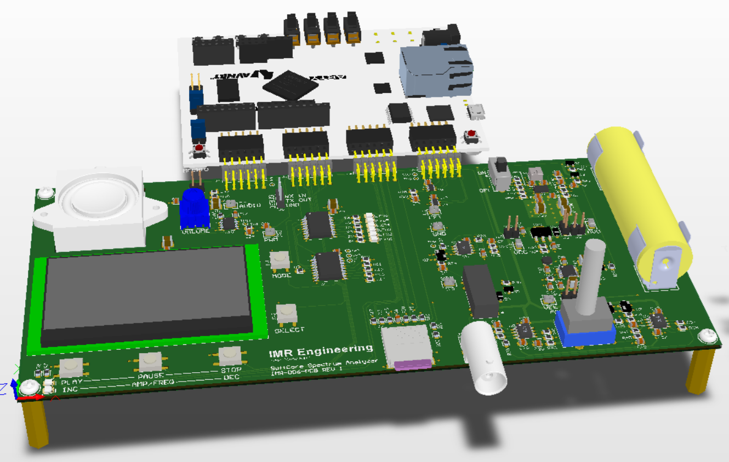

USER MANUAL AND TECHNICAL SPECIFICATION

Principal Engineer: Hab Collector
http://imrengineering.com

Table of Contents
1. INTRODUCTION: 3
1.1 THE PROBLEM: 3
1.2 THE WHAT IF: 3
1.3 THE SOLUTION: 3
2. AT A GLANCE: 4
2.1 FEATURES: 4
2.2 APPLICATIONS: 4
2.3 SIMPLIFIED BLOCK DIAGRAM 5
3. MODES OF OPERATION: 5
3.1 SPLASH SCREEN: 6
3.2 MAIN SCREEN: 6
3.3 CONFIG SCREEN: 7
3.4 SET LIMITS SCREEN: 8
3.5 PHYSICAL CONTROLS: 9
4. TECHNICAL SPECIFICATIONS: 10
4.1 MEASURES 10
4.2 ±VS CURRENT INRUSH MEASURE 11
4.3 INPUT TO OUTPUT 5KHz LOADED AND UNLOADED 12
4.4 Constant Current Mode Enable and Disable 13
4.5 THERMAL PERFORMANCE 13
5. ACKNOWLEDGEMENT 15

DOCUMENT REVISION HISTORY
DATE | DESCRIPTION | EDIT BY
2026-03-06 | Initial draft - Preliminary | HSC

INTRODUCTION:

THE CHALLENGE:
In modern embedded system design the default computational platform is almost always the microcontroller (µC). Devices such as the ARM Cortex M4 provide a powerful and flexible processing environment with a rich ecosystem of development tools, integrated peripherals, and software libraries. For most applications this architecture provides an excellent balance of performance, cost, and development complexity. It is therefore natural to ask an important engineering question: where does a pure PL based FPGA system fit into this landscape? Important distinction: The FPGA in use will be a PL based ONLY not a SOC based.

There is nothing easy about an FPGA – no comparisons will be made there. Instead the challenge explored in this project is not a feature-for-feature comparison between an FPGA and a µC. Instead, the goal is to explore the practical capabilities of a pure programmable logic (PL) FPGA platform by implementing two distinct design projects and observing how such a system compares, in practice, to what might traditionally be implemented on an ARM Cortex M4 class device or higher.

The first phase of this exploration focuses on constructing an FPGA-based system that resembles the functional architecture commonly found in a µC environment. Within the PL, a subset of needed peripherals are implemented which include: UART, SPI, DDR, Timers, PWM, Interrupt Controller, FPU and other system services required to support a complete embedded application. The resulting system demonstrates that the fundamental building blocks normally associated with a µC can be tailored specifically to create the device you need. That said, incorporated into this first project a preview of what lies ahead through the inclusion of two custom RTL-based IP blocks (aka modules) – something you cannot do within a µC.

In the second phase (to come) the focus shifts from “the FPGA can do that too” to “the FPGA can do so much more”. Rather than simply replicating µC peripherals, the design leverages capabilities that are inherently more flexible and impossible via a µC. These include custom hardware processing blocks, internal FIFOs for buffering high-speed data paths, hardware-level signal conditioning, and increasingly sophisticated custom IP blocks such as enhanced ADC interfaces tied to timers and DMA. Much of the infrastructure created in the first phase is reused and extended, allowing the system to evolve beyond a microcontroller-style architecture and into a hardware-accelerated signal processing platform.

PHASE 1 / PHASE 2:
What is covered here is the Phase 1 project design. This document reflects ONLY that which I have completed to date. In doing so I will show performance and limitations thereof, things I got wrong, and issues in hardware, firmware (PS), and PL I intend to correct, and or address in Phase 2.

WHAT IS IT:
A PL based Spectrum Analyzer (SA) implemented around the MicroBlaze softcore processor running on the AMD (aka Xilinx) XC7A100T-1CSG324-1 FPGA. As this FPGA is pure PL there is no PS (Processor System) as in the case of a SoC based FPGA. The system architecture recreates many of the services typically found in a microcontroller environment while remaining entirely within the FPGA PL fabric. The user interface is intentionally simple, and hardware driven, consisting of five multi-function push buttons and a monochrome 128x64 graphical display used for system control and visualization. The device operates as a compact, self-contained instrument designed to demonstrate real-time spectral analysis. The project currently supports two modes of operation: Audio SA (referenced in FW as Audio_SA) and Signal SA (referenced in FW as Signal_SA).

In Audio SA mode the system reads WAV, Pulse Code Modulated 16-bit (PCM16) audio files from a microSD (µSD) storage device and performs real-time spectral analysis on the decoded audio stream. The FW parses the WAV file header to determine parameters such as sample rate, bit depth, channel configuration, etc. then buffers the audio samples for playback and analysis. As samples are decoded, they are simultaneously streamed to the audio output path while FFT size blocks of samples are processed through a Fast Fourier Transform (FFT) to determine the frequency content present in the signal. The resulting spectral information is rendered to the display as a visual spectrum while the audio (PWM decoded) is low-pass filtered and played back through an onboard Class-AB speaker amplifier. Additionally, six colored LEDs (arranged as a bar) display the magnitude (signal strength) of the playback. Both the spectral display and the signal strength LED bar will provide a visual interpretation of the payback audio. This mode demonstrates that spectral analysis can be performed on virtually any uniformly sampled data and highlights the ability to process and display the spectrum in real time. Supporting firmware components (middleware) include: FAT FS File System, u8G2 Graphics Library, and the KISS FFT library for spectral computation.

Signal SA mode is the second mode of operation. In this configuration the device works as a traditional Spectrum Analyzer to convert and display incoming analog signals to the frequency domain. For demonstration and portability purposes, the system includes an onboard local oscillator capable of generating a test signal that can be analyzed directly by the instrument. Analog input is selectable via the UI as the local oscillator or via the external BNC connector. The sampled signal is digitized through the custom RTL IP ADC interface and processed using the same FFT-based spectral analysis pipeline used in audio mode. The resulting frequency spectrum is then displayed on the graphical interface.

AT A GLANCE:

PL FEATURES:
- MicroBlaze softcore with 64KB / 32KB of Instruction / Data Cache, FPU and 128KB of LBM (volatile fast memory)
- 3x Timers (two with interrupts)
- PWM
- 2x SPI interfaced to 3x Peripherals
- UART
- DDR3 Interface to external 128Mx16 (MT41K128M16XX-15E)
- 11x GPIO Outputs
- 12x GPIO Inputs
- Custom RTL Revision IP
- Custom RTL ADC Interface IP
- Interrupt Controller with 3x Fast Interrupts

HW FEATURES:
- IO Expander to LED outputs
- IO Expander to UI push button Inputs
- Micro-SD
- 128x64 2.42” OLED Display
- Dual 12b 1MSPS ADC
- Sallen Key LPF
- Selectable Analog inputs to Signal SA
- Local Variable Oscillator 4.4K to 48.2KHz
- Class AB Audio Amplifier
- Single Li-ION cell operation
- Interface to Digilent Arty A7 Development board

FW FEATURES:
- Bear Metal Application
- Middleware: FAT FS Library
- Middleware: U8G2 Graphics Library
- Middleware: KISS FFT Library
- Two modes of operation

SIMPLIFIED BLOCK DIAGRAM
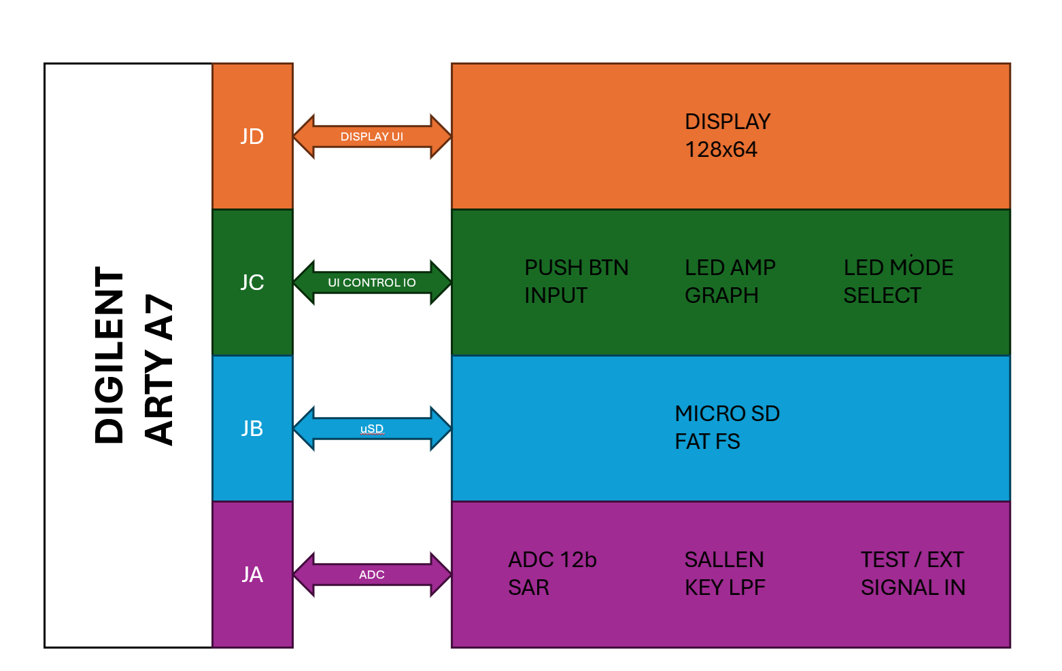

PROJECT SCOPE:
When creating a two-part project of such hardware and firmware complexity, as a one-person show, limiting scope is necessary to ensure time, budget and project momentum are kept.

FIRMWARE:
For firmware I decided to implement a bear-metal application rather than an RTOS. It limited FW complexity for one, but it also availed the processor of the memory and processing time needed to support an RTOS. The choice of KISS FFT pre-existing library was also necessary as a custom FFT library would be a project on to itself.

HARDWARE:
The complexity of layout for a DDR3 memory and the layer count associated with such a design from a cost and time perspective made the choice of using the off the shelf Digilent Arty A7 Development Board an easy choice. Having designed both FPGAs and DDR3 memories before I knew ahead of time I was looking at 3 revisions of a 6 layer PCB. More so, I have chosen not to extend my Altium license moving forward, the need for trace impedances and serpentine routing neither of which is supported by Circuit Studio (development tool used). For the same reasons the choice of a simple display was made over an RGB color model.

MODES OF OPERATION:
- Audio Spectrum
- Signal Spectrum

AUDIO SA MODE DETAILS:
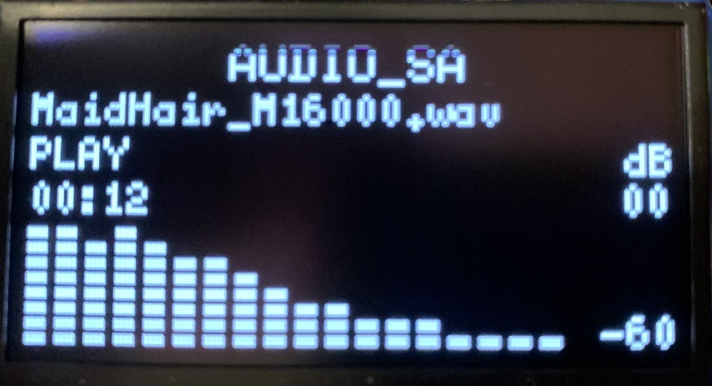

In Audio SA mode the system operates as a real-time audio playback and spectral display instrument. Audio content is read from a WAV file stored on the µSD card using the FAT FS middleware. Once the file header is parsed and verified, audio sample data is moved from storage into a large streaming buffer sized at 22K samples / 44KB. This large buffer exists to reduce the frequency of µSD card read operations and to provide margin against storage access latency. From this streaming buffer the system fills a smaller 4KB feed buffer which serves as the more immediate source for playback and FFT sample collection. In this way the buffering scheme is staged: mass storage feeds the large streaming buffer, the streaming buffer feeds the smaller feed buffer, and the feed buffer supports both playback and FFT processing.

Playback timing is controlled by a timer interrupt service routine (ISR) configured to run at the audio playback sample rate. For a playback rate of 16KHz, the ISR period is:
$$T_{sample}=\frac{1}{16000}=62.5 μs$$This means one audio sample is processed every 62.5µs. As playback proceeds, samples are simultaneously routed to the PWM audio output path and copied into the FFT sample buffer. The FFT sample buffer contains 1024 samples, therefore the time required to fully populate it at 16KHz is:
$$T_{FFT Fill}=\frac{N}{Fs}=(\frac{1024}{16000})= 64 ms$$
Thus, under continuous playback, a new 1024-point FFT frame becomes available every 64ms. This corresponds to an FFT update rate of:
$$\frac{1}{0.064}=15.625 Hz$$or approximately 15.6 spectral updates per second. As an additional reference, the 4KB feed buffer holds 4096 bytes. For 16-bit PCM audio, each sample is 2 bytes, giving:
$$\frac{4096}{2}=2048 samples$$At 16KHz playback this buffer represents:
$$\frac{2048}{16000}=128 ms$$of mono audio data. Likewise, the 44KB streaming buffer holds:
$$\frac{44056}{2}=22528 samples$$
which at 16KHz corresponds to:
$$\frac{22528}{16000}=1.408 s$$
or about 1.4 seconds of mono playback data. These staged buffer depths are what allow playback, storage access, and FFT processing to coexist with acceptable continuity.

Interrupt handling is a significant part of the design – its importance cannot be overstated for this project. As such I take a moment to expand upon it here. Both modes rely heavily on the sample rate interrupt timer (AXI Timer 1). The MicroBlaze is capable of normal and low latency (fast) interrupts. Normal interrupts use the AXI interrupt controller and are decoded, prioritized and vectored to the processor. Normal interrupts take about 40 cycles between detection to ISR jump. Fast interrupts bypass the interrupt controller and connect directly to the MicroBlaze. Subsequently fast interrupts are processed within about 10 cycles, generally speaking, on par with ARM Cortex M4. That said, most M4 and M7 designs clock in excess of 100MHz, so the actual time from detection to ISR jump and ISR processing is less. Part of the interrupt mechanism is architectural, and part is simply clock speed (cycle time): The phase 1 design runs at 100MHz. In phase 2 I will attempt to run the same design to 150MHz. A difference with a distinction. While µCs are typically specified with a fixed max clock speed, FPGAs come in speed grades -1, -2, -3 (slow, faster, fastest). Generally speaking the speed grade represents a “possible” range of the max fabric clock frequency. At speed grade 1 is maybe possible to get a max of 200MHz. If this is repeatable across devices will be device and design dependent. That said, 100MHz is just a known starting point. Nesting, the MicroBlaze interrupt controller does not support a true nested interrupt model where one interrupt preempts another already in service, though it does support interrupt priority. In this project that reality strongly influenced the overall firmware architecture, the selected FFT size, and the balance between playback, analysis, and display update rate. Lastly, all ISR are placed in (Local Block Memory) LBM (FPGA block RAM directly attached to the MicroBlaze – runs exceptionally fast) and not within DDR3 space. The overall size of the application dictates that most of it run from DDR3 space, targeting LBM for specific use where speed is paramount.

SIGNAL SA MODE DETAILS:
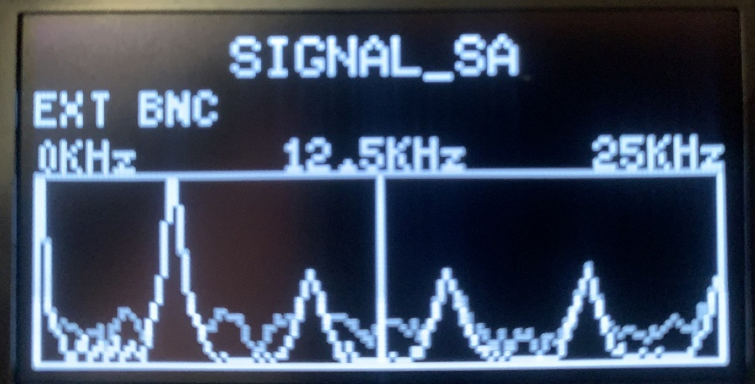

In this configuration the instrument functions as a traditional Spectrum Analyzer by converting incoming time-domain signals into its frequency-domain representation. While the sampling data differs from Audio SA mode, the spectral analysis engine remains fundamentally the same. Both modes leverage the same FFT algorithm and the same 1024 samples per frame,

Signal acquisition begins with the sample-rate timer interrupt. Each interrupt event initiates the sampling sequence by triggering the custom ADC RTL IP to perform an ADC conversion. The ADC interface implemented in PL controls the timing of the conversion and provides the resulting digital sample to the firmware via a fast interrupt. Within the ISR the sample is transferred into the FFT sample buffer, where samples are accumulated until the frame buffer (1024 samples) is full.

Once the frame is complete, the spectral processing routine is executed. During this time the ISR is suspended. The resulting magnitude values represent the spectral energy distribution of the input signal and are mapped to the display. Once the display has been updated the ISR is resumed. This produces a real-time visualization of the signal’s frequency content.

Input signals can originate from two sources. The onboard, variable Wien Bridge Oscillator (4.4KHz to 48.2KHz) or via an external BNC connection. As with Audio SA mode, the entire signal acquisition and analysis pipeline is driven by the timer interrupt architecture. The interrupt establishes the sampling cadence, triggers ADC conversion, and governs the rate at which samples are collected for FFT processing. Consequently, the overall performance and responsiveness of the Signal SA system are fundamentally driven and limited by the ISR-based architecture.

In this mode the only active control is Select. Toggles between the on board ossiclator and the external BNC

Below shows the timing interactions:
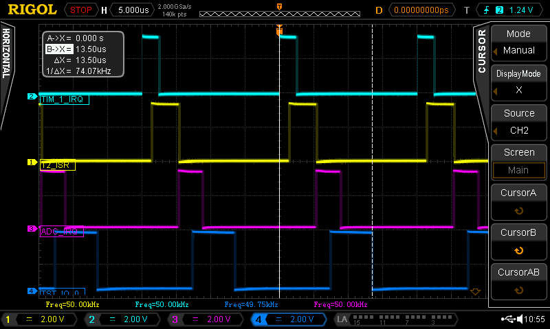
NOTES:
CH2 - TIM_1_IRQ: Timer 1 IP IRQ
CH1 - T2_ISR:
Timer 1 ISR handler (inniates Custom RTL ADC conversion)
CH3 - ADC_IRQ: Custom RTL ADC conversion complete IRQ
CH4 – TEST_IO_0: ADC IRQ ISR complete (the sample has been captured)
Cursor Marking: Shows the max frequency possible for sampling about 74KHz – choose 50KHz for sampling frequency.

As the above timing analysis shows the max sample rate possible using this architecture resolves to an absolute maximum of 70KHz (allowing some wiggle room from the 74KHz). As such for phase 1 I settled on a sample rate of 50KHz, which implies a usable frequency BW of 25KHz. The target sample rate I had hoped to achieve was 100KHz given an observable frequency band width of 50KHz. The local Wien Bridge Ossiclator was designed to be in this band 4.5KHz to 48.2KHz

PHYSICAL CONTROLS:
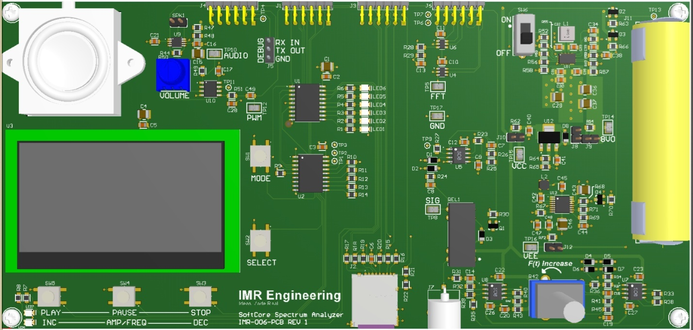
The UI interface consists of:
AUDIO:
- SW1: MODE: Toggles between Audio and Signal Spectrum Analyzer
- SW2: SELECT: Selects the next audio track
- SW3: STOP: Stop playing audio
- SW4: PAUSE: Pause the present audio playback
- SW5: PLAY: Play the selected track
SIGNAL:
- SW1: MODE: Toggles between Audio and Signal Spectrum Analyzer
- SW2: SELECT: Selects between local oscillator and external BNC
- *As the observable BW is only 12.5KHz, ¼ that of the original objective for phase 1 – I saw no sense in elaborating on the controls

TECHNICAL SPECIFICATIONS:

MEASURES
ABSOLUTE MAX RATINGS
PARAMETER | CONDITION | Min | Typ | Max | UNIT
ENVIRONMENTAL
Operating Temperature |  | -20 |  | 30 | ºC
Storage Temperature |  | -40 |  | 85 | ºC
Relative Humidity | Non-condensing |  |  | 97 | %
SINGLE CELL SUPPLY
+VS Supply rail |  | 3.4 | 4.2 |  | V
EXTERNAL BNC INPUT
Input |  | -0.7 | 3.0 | 3.3 | V

OPERATIONAL SPECIFICATIONS
PARAMETER | CONDITION | Min | Typ | Max | UNIT
ENVIRONMENTAL
Temperature |  | -20 |  | 30 | ºC
Relative Humidity | Non-condensing | 0 |  | 95 | %
PHYSICAL DIMENSIONS
Length |  |  | 210.0 |  | mm
Width | Does not include connectors |  | 100.0 |  | mm
Height | Lowest to highest measure wo post |  | 15.0 |  | mm
INPUT SIGNAL
Impedance |  |  | 1M |  | Ω
Voltage Range |  | .01 |  | 3.0 | V
AUDIO
WAV File Type | PCM |  | 16 |  | bit
Audio Sample Rate |  | 8 |  | 16 | KHz
Voume | Measured at 0.5m |  |  | 85 | dB
Peak Power | Max peak time 5s at Ambient 25°C |  |  | 60 | W
Continuous | Ambient 25°C |  |  | 25 | W
Current Measure (Reading)  Iout = Output Current | ⁴ Iout > 100mArms to limit  ⁴ 30mA < Iout < 100mArms  ⁴ Below 30mArms no statement | -1.0  -10m  NA | NA | +1.0  +10m  NA | %  Arms
POWER CONSUMPTION
Load on -VS supply rail | ³No output loading |  |  | -10 | mA
Load on +VS supply rail | ³No output loading |  |  | 330 | mA
Switch in OFF position |  |  |  | 45 | µA
FREQUENCY AND SAMPLE RATE
Input frequency range |  | 0 |  | 7.812 | KHz
Sample Rate ±VS, Vin, Output Amps |  |  | 64.00 |  | µs
Sample Rate 3.3V & Temperature |  |  | 71.11 |  | µs
CONSTANT CURRENT MODE
Time to 95% convergence CC |  |  |  | 310 | ms
Time to CC mode deactivated | Removal of fault load |  |  | 200 | ms

NOTES:
¹In constant current mode the gain is adjusted in steps via 256 steps from unity to with the first non unity gain decreasing occurring at 0.9961V/V and the last at incremental step at 0.0039V/V
²Output power is limited by the ability to dissipate heat to keep the output amplifiers junction temperature below 160°C. The amplifier’s dissipated power can be approximated by the equation: (Vs nominal – Output Voltage) x Output Current
³±VS nominal supply. Output to both channels switched on. Both fans are on. Input impedance both channels set to 50Ω. There is no output load.
⁴Below 30mArms current what is displayed is the mean not RMS current. Two different ranges for accuracy are given, below and above 100mArms.

±VS CURRENT INRUSH MEASURE

+VS Current Inrush Measure
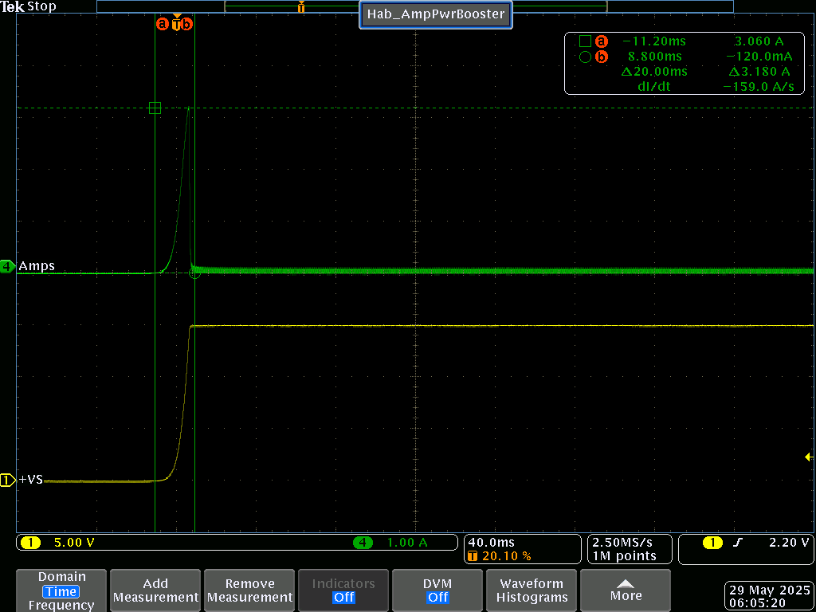
- As measured at POR (Power On Reset)
- NO OUTPUT LOAD

-VS Current Inrush Measure
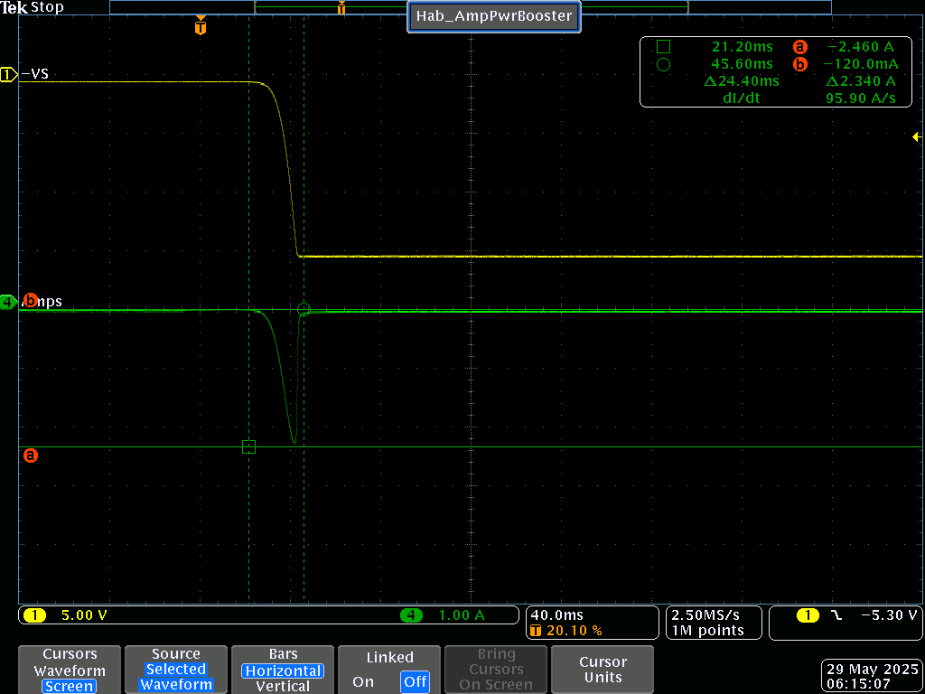
- As measured at POR (Power On Reset)
- NO OUTPUT LOAD.

INPUT TO OUTPUT 5KHz LOADED AND UNLOADED

Input Output Response 5KHz No Load
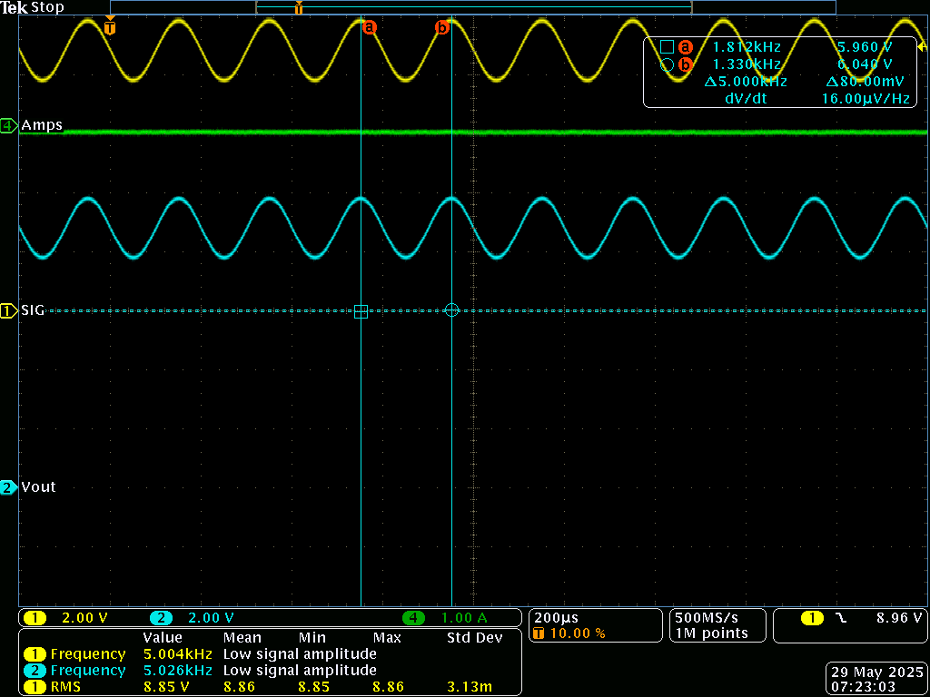
- No measurable change in phase or frequency input to output
- Vin as measured by ARB = 8.93

Input Output Response 5KHz to 8Ω Load
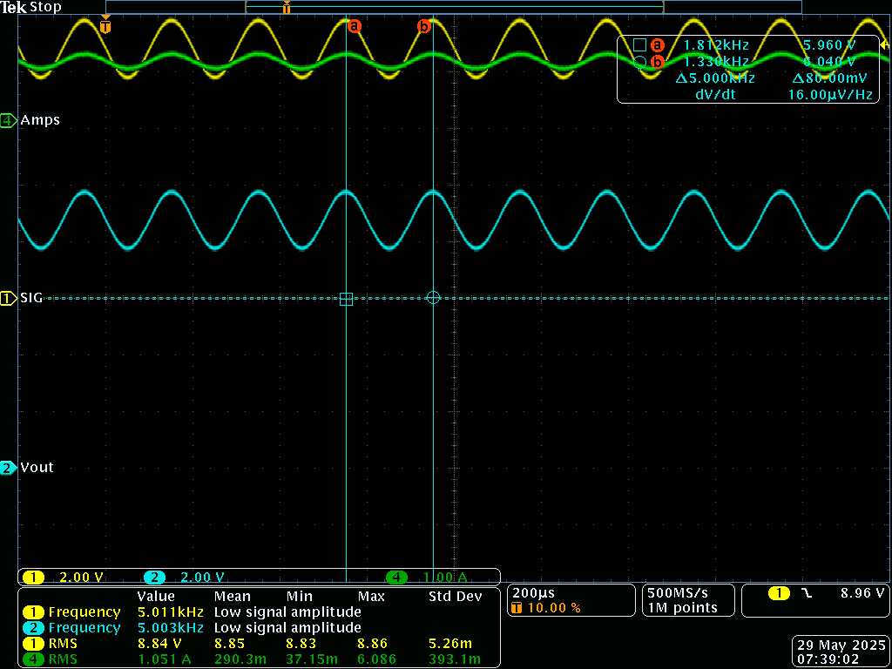
- No measurable change in phase or frequency input to output
- Vin as measured by ARB = 8.92Vrms
- Iout as measured by ARB = 1.061Irms
- Power To Load = 9.29W

Constant Current Mode Enable and Disable
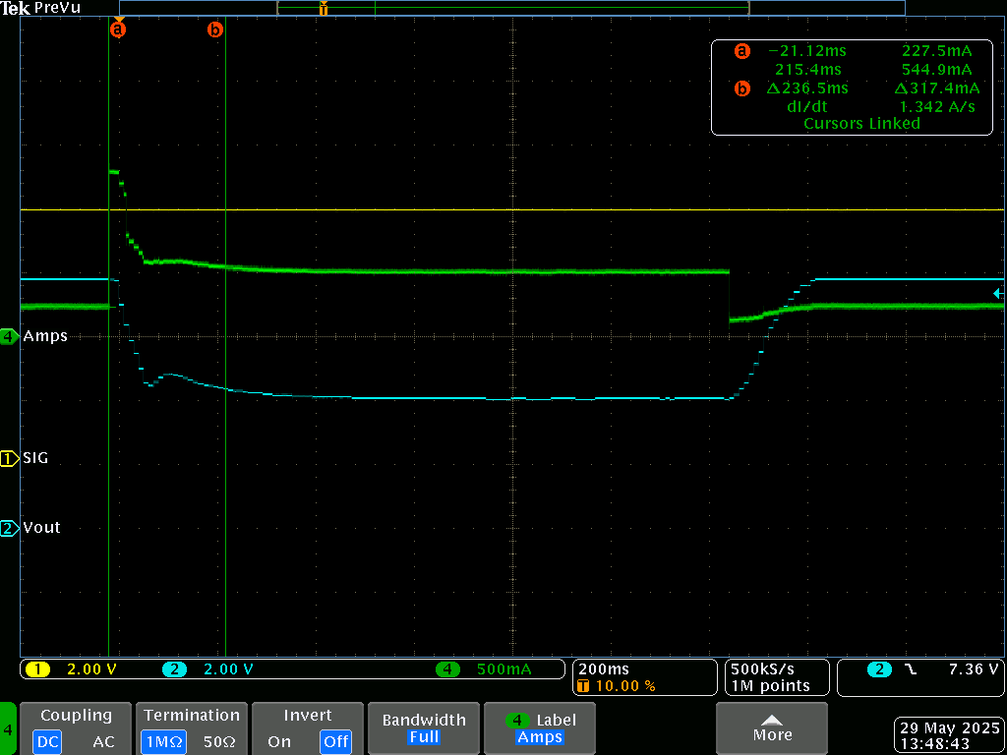
- CC Mode Limit set to 500mA
- Vin 8V
- Vout adjusted based on CC PID to match limit set point of 500mA
- Enable:
  - From a running load of 250mA a fault load of 1A is applied
  - CC mode activates in 236ms (to 95%)
- Disable:
  - From 500mA CC the fault load is reduced to 250mA
  - CC mode disable (150ms)

THERMAL PERFORMANCE

SETUP
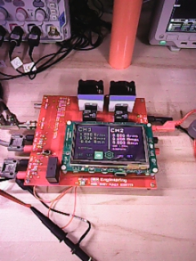
- Connected to 8Ω 100W resistor load not shown

THERMAL IMAGE CHANNEL 1
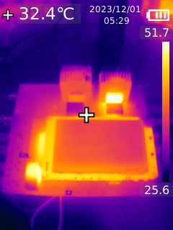
- On Time = 20min
- Output Current = 1.061Arms
- Output Voltage = 8.92Vrms
- PCB PLATED TO 1Oz
- Thermal camera not calibrated, temperature information is incorrect (not nearly that hot), but the image is useful in that you can see heat not being transferred to the heat sink – nothing here was hot to touch.

ACKNOWLEDGEMENT

FAMILY:
To the keeper of me, my beloved wife, I share everything with you. You are my strength in weakness, clarity in uncertainty and applause in victory. I accomplish nothing without your support, nor is anything of worth unless I can share it with you. I love you.

To my daughter Christina, we have had our challenges. In part, and in this, I hope one day in you the understanding of what I have been trying to say. Love is what you do. You are exceptional in so many ways; add to your gifts hard work and the world is yours.

To my daughter Faith, the Humanitarian, it is clear that you belong to the goodness of this world. You must remember that true greatness is only realized through service and that there are many ways to serve. Therein will be your pursuit – run to catch it. I hope I have shown you how to run.

To my daughter Trinity, the scientist, there is a clarity in the way you speak and think, in your questions and answers. You are to add to the scientific collective. Of the three, you are most like me. Don’t be afraid, nor ashamed of whom you are; accept it, and work hard to be.

To God Almighty, it is you that have made me, and not me myself – thank you for the many blessings, may I be a better servant and steward.

FRIEND:
Special thanks to my friend Walter Varda an absolute Rock Star of analog engineering and an even better person. His input in the earlier stages of the amplifier design process was most helpful to this project. Thank you Walter, you are one of the most generous people I have ever met in my life.

